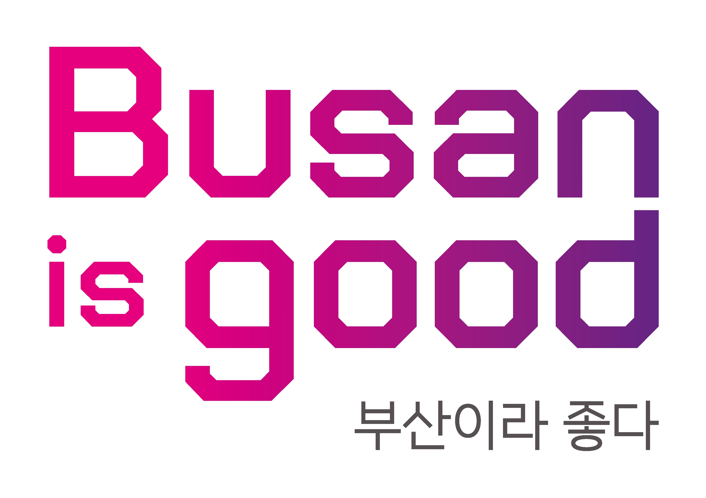


From Busan to the World: Connecting Youth
[BGCF 2026 Global Youth Ambassadors Program]

November 12th (Thursday) ~ November 18th (Wednesday), 2026
[6 nights, 7 days]

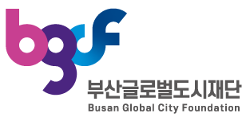

Index

1. | PROGRAM INFORMATON | 3
2. | RECRUITMENT DETAILS | 6
3. | USEFUL INFORMATION | 7
4. | CITY OVERVIEW | 9
5. | INTRODUCTION TO THE INSTITUTION | 10

PROGRAM INFORMATON

- Overview
• Title: [Busan Global City Foundation] 2026 Global Youth Ambassadors Program
• Period: November 12th (Thu) ~ November 18st (Wed), 2026 (6 nights, 7 days)
• Venues: The area of Busan Metropolitan City, South Korea
• Participants: (Approx.) total 30 Global Youths
*along with ‘2026 Eurasia City Diplomacy Corps’
- 20 Global Youths from 4 Cities(Countries) (5 youths from each city)
[China (Shanghai), Kazakhstan (Almaty), Uzbekistan (Tashkent), United Kingdom (Liverpool City Region)]
- 10 Youths from Busan City
• Must Required: Fluent English Communicator
*working languages: English and Korean
• Program
- Opening and Closing Ceremony
- Campus tours of universities in Busan, K-culture experience programs
- Theme missions(team presentations), cultural tours, field trips, and exchanges with Korean students
- Participating in conventions and related events in Busan
• Expense Breakdown
- Participant Expenses: Round-trip plane tickets, Visa or K-ETA issuance fee, Overseas travel insurance costs, Airport(Incheon) <-> Busan transportation costs, Other personal expenses (emergency medicine, souvenirs, etc.)
- Organizer(Host) Expenses: Expenses incurred while staying in Busan [accommodation, meals, cultural experience, transportation in Busan City
• Host: Busan Global City Foundation(BGCF)

- Schedule [*programs are subject to change]
Date | Program | Note
Day 1 | "Welcome to Busan City"  ○ Arrival of overseas participants and hotel check-in | - November 12th-18th, 2026  (6 nights, 7 days)  - Expenses covered by BGCF:  Accommodation, meals, local transportation, cultural experience fees and any other expenses incurred during the stay in Busan  - Expenses covered by participants:  Round-trip airfare, visa and K-ETA application fees, overseas travel insurance, round-trip transportation between Incheon and Busan, and other personal expenses  - Working Languages:  English and Korean  - Eligibility:  ․ Aged 19-34  ․ Physically and mentally healthy  ․ Strong interest in Korean and other cultures, and willing to actively introduce their own culture  ․ Proficient in English communication
Day 2 | “Global Youth Ambassadors' Kickoff:  Meet & Begin”  ○ Opening Ceremony  ○ Orientation and ice-breaking session  ○ Vists to the ‘Busan Intl’ Medical Tourism Convention 2026’
Day 3 | “Busan, Culturally Vibrant City”  ○ K-Temple experience  ○ K-Dessert making experience  ○ K-Martial arts(Taekwondo) experience
Day 4 | "Busan, a City by the Sea"  ○ Arte Museum Busan, Busan Aircruise(Song-do)  ○ Haeundae Tour(X the Sky, Blueline Park)
Day 5 | “Feel the Busan”  ○ Industrial site visits to Busan-based companies  ○ K-Culture experience(Hanbok Wearing)  ○ Campus Tour in Busan
Day 6 | “Big Shout-out from Busan”  ○ KF Asean Culture Center Tour  ○ Visits to Busan Metropolitan City Hall  ○ Team-based Theme Mission presentations  ○ Closing Ceremony
Day 7 | "See you, Busan"  ○ Hotel check-out and departure of overseas participants

- Transportation Information
Date | City | Content | Note
Nov. 12th | Busan | Gimhae(Busan) International Airport / Busan Train Station(KTX) → Hotel(Busan) | BGCF can provide the transportation to Hotel.  *BGCF staff will welcome you  at the Gimhae Intl Airport / Busan Station.
Nov. 13th  ↓  Nov. 17th | Busan | Tour Schedule in Busan | Travel in a group (BUS)  (BGCF will provide the transportation)
Nov. 18th | Busan | Hotel(Busan) → Gimhae International Airport / Busan Train Station(KTX) | BGCF can provide the transportation to Gimhae Intl Airport / Busan Train Station.  *Transportation to Incheon International Airport will be at the participants' own expense.

- Photos related to the last year’s program
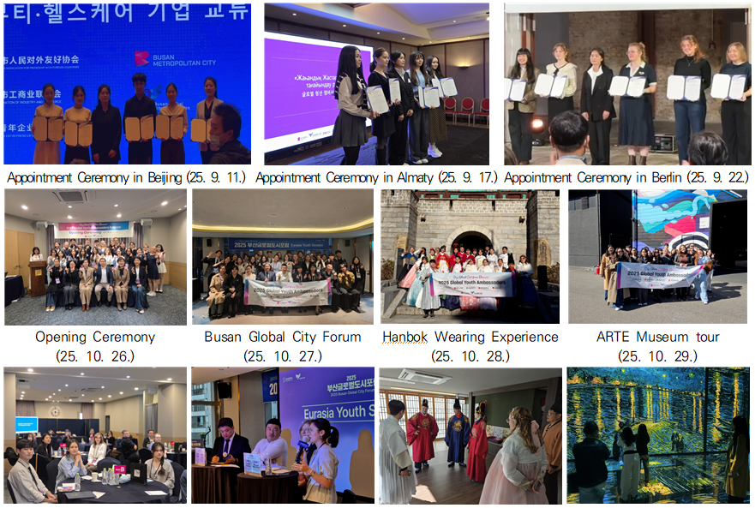

RECRUITMENT DETAILS

Participant Recruitment
• Recruitment Period: until July, 2026
• Recruitment Target: Youth representatives aged 19-34 from 4 countries
• Number of People Recruited: maximum 30 global youth people
(five youths from each country / 5~10 youths from Busan City)
- 20 Global Youth from 4 Cities(Countries) (5 youths from each country)
[China (Shanghai), Kazakhstan (Almaty), Uzbekistan (Tashkent), United Kingdom (Liverpool City Region)]
• Documents to be submitted: Application Form, Copy of participant’s Passport
• Submit: 9409kankan@naver.com (by July 31st, 2026)
• Participant Recruitment Schedule

1  Proposing  official letter to partner organizations  overseas  (request for GYA recommendations) |  |  | 2  Participant Recommendations /  Recruitment  (by partner organizations) |  |  |  | 3  Final selection and Confirmation of Participants  (by partner organizations and BGCF) |  | 4  Submitting Information of Airline Tickets, Overseas Travel Insurance, Visa, K-ETA, etc  (by participants)
April 2026 |  | April-July 2026 |  |  |  | July-August 2026 |  |  |  | ~ September 30, 2026
Proposing Participant Recommendation Letters, Program Overview, and Participation Application Form |  | Receiving and Confirming Participation Application Forms  *If unable to recruit or attend, additional recruitment will be held in other cities |  |  |  | Reconfirming Participants by Country, Organizing and Sharing the Final List  *no. of participants may be adjusted by BGCF. |  |  |  | Airline Ticket Reservation (individually), Visa Application (If necessary, an official document to cooperate with Visa issuance will be sent)  * Overseas Travel Insurance (required)
<Participant Eligibility Requirements>
• Ages 19-34: Those who have no difficulty communicating and understanding English;
• those who have no physical or mental difficulties when traveling abroad;
• those who have no problems with Visa issuance;
• those who can purchase a round-trip airline ticket (expenses such as accommodation, food, activities, etc. will be supported by BGCF);
• those who can use MS PowerPoint and make presentations based on group mission activities; and those who are interested in introducing their own culture and learning about other cultures.
USEFUL INFORMATION

- Visa Information
Division | Country | Note
No Visa  (short-term visit) | Kazakhstan, United Kingdom | • However, for Kazakhstan, a K-ETA (Electronic Travel Authorization of Korea) must be issued 72 hours before departure to enter Korea.  • Reference:  - Republic of Korea Ministry of Justice Electronic Travel Authorization Center  https://www.immigration.go.kr/immigration_eng/index.do  - K-ETA  https://www.k-eta.go.kr/portal/guide/viewetaalification.do  - Reference: Ministry of Foreign Affairs  https://www.mofa.go.kr/eng/nation/m_4902/list.do
Visa  Required | China,  Uzebekistan | • Please refer to the Korean Embassy in your country  (the country of your passport issuance)  • Note: If you have any documents required for Visa issuance,  please contact us as soon as possible.

✅ Visa & K-ETA Requirements for Entry into South Korea (as of March 2026)
Country | Visa Required | K-ETA Required | Notes
China | Yes | Not applicable | Visa is required for individual tourist
Kazakhstan | No (up to 30 days) | Required | K-ETA is mandatory for short-term stays
Uzbekistan | Yes | Not applicable | Visa is required for all entries
United  Kingdom | No (up to 90 days) | Exempt until  Dec 31, 2026 | Arrival card must be completed  if K-ETA not applied

- Hotel Information [*subject to change]
City | Hotel | Contact | Address | Check-in | Check-out | BF | Toiletries
Busan | Busan City Hotel | +82-51-851-1122 | 19, Sinchon-ro, Yeonje-gu, Busan | 15:00 | 11:00 | Yes | Yes

- Other Useful Information

Division |  | Content |  | Remark
Korean currency  (KRW) | Bills | 1,000 won, 5,000 won,  10,000 won, 50,000 won |  | 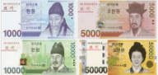
Korean currency  (KRW) | Exchange rate | 1,498 won to the US dollar |  | As of March 2026
Korean currency  (KRW) | Credit cards | Visa and Mastercard accepted
Korean currency  (KRW) | ATMs | Located in public places, shopping malls, etc.
Korean currency  (KRW) | Carry-on cash  (when entering  Korea) | Each person can carry  US$ 10,000. |  | If the account exceeds US$10,000, it must be  reported to customs.
Weather Guide for Busan  (November) | Mild and pleasant, though mornings and evenings can be chilly | -Average Temperature: 13-15°C  -Daytime High: 18-20°C  -Nighttime Low: 8-10°C |  | Coastal areas may feel colder due to wind.  * Rainy season  (umbrella required)
Dress code | Opening/Closing ceremony | Neat and smart casual attire | Other events |  | Free attire
Electricity | 220V, 60Hz | 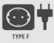
Insurance | Overseas travel insurance (required)  The organizer does not have insurance for participants and is not responsible for any accidents during the event.
Materials needed | Identification: Passports, a copy of the first page of the passport, 2 passport photos  Daily necessities: Umbrellas, rechargers, hats, etc.  Sanitary products: Sunscreen, toiletries, cosmetics, towels, tissue, etc.  Emergency goods: Motion sickness medicine, cold medicine, antidiarrheal medicine, headache medicine, bandages, digestive medicine, painkiller, ointment, disinfectant, etc.  Local activities: Writing instruments, materials to distribute, etc.  Souvenirs from each Country(for souvenir exhibition)
Tips and  Taxes | Tipping is not a common practice in Korea, and there is no need to leave a tip unless expressly stated. Most restaurants and hotels apply a 10% VAT directly to your bill, including gratuity, so workers do not expect tips.
Other Contact Information
  Division | Mon. – Fri. |  | Sat. Sun., Holidays
  Banks | Administrative agencies |  | Closed
  09:00 – 16:00 | 09:00 – 18:00* |  | Closed
  Shopping malls | Post Office | Shops | Closed
  10:30 – 20:00 | 09:00 – 18:00 | 09:00 – 22:00 | Closed
  Police (emergency line) | Emergency responders,ambulances, firefighters | Korea Disease Control and Prevention Agency | Flight Information  (Gimhae International Airport)
  112 | 119 | 1339 | 1661-2626
CITY OVERVIEW

Busan Metropolitan City

Division | Content
General Information | A metropolitan city located in the southeast of Korea. It borders Yangsan-si, Gyeongsangnam-do and Ulju-gun, Ulsan Metropolitan City to the north, and Changwon-si and Gimhae-si, Gyeongsangnam-do to the west.  It is the second-largest city in Korea after Seoul and the first ‘directly-control’ metropolitan city. It is the most populous of the six ‘semi-autonomous’ metropolitan cities. Along with Gyeongsangnam-do province, it is the only administrative unit with a population of 3 million in southeast South Korea. If the scope is expanded to include all administrative units in South Korea, it is the third most populous after Gyeonggi-do and Seoul.
Population | 3.4 million people
Area | 770.13㎢
Administrative district | 15 districts (gu), 1 county (gun), 205 (eup, myeon, and dong)
Homepage | https://www.busan.go.kr
The Logo of  Busan |  | The English initials B and S of Busan were used as a motif, and the vision and values ​​of Busan were symbolized through angles and colors. The natural connection between purple (magenta) and blue (cyan) symbolizes the inclusiveness and harmony of Busan citizens, and the use of three-dimensional colors expresses the smooth connection between Busan's past, present, and future in a three-dimensional way.
The Flower of  Busan |  | The Camellia flower was officially designated on Mar. 1st, 1970, and the Camellia tree was selected on Jul. 1st, 1970.  The combination of dark green leaves and crimson flowers depicts the blue sea and the loving spirit of citizens, while the fresh and shiny dark green broad leaves represent the youth and motivation of citizens.
The Bird of  Busan |  | Seagull was designated on Jul. 1st, 1978.  The pure white wings and body symbolize white-clad people (the Korean people). The strength of the seagull, which patiently flies in the sky along a long sea route, was a reason for the seagull to be chosen as the bird of Busan because it genuinely represents the spirit of Busan citizens.
The Fish of  Busan | 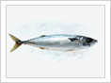 | Mackerel was designated on Jul. 6th, 2011  『Dynamic, Powerful, Speedy』  It symbolizes Busan, a marine and fisheries city that constantly leaps toward its goal with strong power across the Pacific Ocean.
INTRODUCTION TO THE INSTITUTION (Organizer)
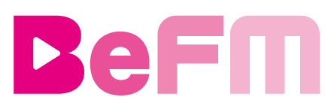
Busan Global City Foundation

□ Establishment
▪ Year of Establishment: November 25, 2005
▪ Purpose of Establishment: Promoting the revitalization and systematic promotion of
international exchange work and English broadcasting work
□ Busan Global City Foundation’s Vision
Busan Global City Foundation is a public diplomacy and media organization that brands ‘Busan, a global hub city.’ In line with Busan City's vision of urban diplomacy, various projects are being promoted, such as creating a foundation for revitalizing international exchange and cooperation projects, support for foreign expats, and multilingual broadcasting.
□ Major Projects
▪ International exchange and cooperation project, creating a better city for foreign residents to
live in, future strategic talent development projects
▪ Provision of information and knowledge through multilingual broadcasting, including English, Chinese, and Vietnamese, and planning, programming, and production of broadcast programs
▪ International exchange cooperation projects with overseas broadcasting companies and foreign
language education-related projects
□ Directions
▪ Address: 13FL. National Pension Service building, Jungang-daero 1000, Yeonje-gu, Busan
▪ Transportation:
Subway: exit gate #2 at the City Hall Station (Line 1)
Bus: get off at the City Hall bus stop (bus no. 29, 86, 87, 99, 110-1, 131, 141, 179, 1010)
Car: 1 hour free parking (1,000 Korean won per 10 min after 1 hour)

CONTACT
Busan Global City Foundation (BGCF) / Global Hub City Dept.



▪ Phone: +82-51-711-6875
▪ E-mail: 9409kankan@naver.com
▪ Website: https://bgcf.or.kr/
▪ Program Coordinator: KANG, Changhwa
▪ SNS accounts: KakaoTalk @9409kan / WhatsApp WeChat

